

Penrhos College
Semester 2 Examination, 2011

Question/Answer Booklet

MATHEMATICS SPECIALIST:
3C/3DMAS
Section Two:
Calculator-assumed

Student Name:____SOLUTIONS_____

Time allowed for this section

Reading time before commencing work: 10 minutes
Working time for section: 100 minutes

Material required/recommended for this section

To be provided by the supervisor
Question/answer booklet for Section Two. Candidates may use the removable formula sheet from Section One

To be provided by the candidate
Standard items: pens, pencils, pencil sharpener, highlighter, eraser, ruler
Special items: drawing instruments, templates, notes on up to two unfolded sheets of A4 paper, and up to three calculators, CAS, graphic or scientific, which satisfy the conditions set by the Curriculum Council for this course.

Important note to candidates
No other items may be taken into the examination room. It is your responsibility to ensure that you do not have any unauthorised notes or other items of a non-personal nature in the examination room. If you have any unauthorised material with you, hand it to the supervisor before reading any further.

Instructions to candidates
1. All questions should be attempted.

2. Write your answers in the spaces provided in this Question/Answer Booklet. Spare answer pages may be found at the end of this booklet. If you need to use them, indicate in the original answer space where the answer is continued (i.e. give the page number).

3. Show all your working clearly. Your working should be in sufficient detail to allow your answers to be checked readily and for marks to be awarded for reasoning. Incorrect answers given without supporting reasoning cannot be allocated any marks. For any question or part question worth more than two marks, valid working or justification is required. If you repeat an answer to any question, ensure that you cancel the answer you do not wish to have marked.

4. It is recommended that you do not use pencil except in diagrams.

Section Two: Calculator-assumed (80 Marks)

This section has twelve (12) questions. Answer all questions. Write your answers in the space provided.

Suggested working time for this section is 100 minutes.

Question 9 (4 marks)

Use proof by exhaustion to prove that 127 is a prime number.

Solution
If 127 is a prime number it is not divisible by another prime number.

127 ÷ 2 = 63.5
127 ÷ 3 = 42.3
127 ÷ 5 = 25.4
127 ÷ 7 = 18.14
127 ÷ 11 =11.55

As there can be no other prime factors of 127.
∴ 127 has no other factors other than 1 and itself
i.e. 127 is prime
Specific behaviours
States that a prime number is not divisible by another prime number
✓ Follows process of exhaustion for dividing 127 by all possible prime numbers
States why the process is exhausted
establishes correct conclusion

Question 10 (9 marks)

The triangle ABC with vertices A(0, 0), B(3, 1) and C(-1, 2) is transformed by the matrix on to the triangle A'B'C'.

(a) Determine the coordinates of A' and C'.
[2]
Solution
A'(0, 0).
C’(4, 1)
Specific behaviours
correctly determines A’
correctly determines C’

(b) The area of triangle A'B'C' is 7 square units. What is the area of triangle ABC?
[2]
Solution
Area of ABC = 7 ÷ ⏐2⏐
= 3.5 units²
Specific behaviours
correctly calculates the value of the determinant
correct area of triangle

(c) Matrix M represents a combination of transformation X followed by transformation Y. If the matrix for transformation , determine the matrix for transformation Y and describe the geometric transformation Y represents.
[3]
Solution

Y represents a dilation factor 2 parallel to x-axis
Specific behaviours
correctly acknowledges YX = M
correctly calculates matrix Y
correctly describes matrix Y geometrically

(d) The triangle A'B'C' then undergoes a shear of factor parallel to the y-axis such that the image of the coordinate C' is (4, -3). Determine the value of.
[2]

Solution
Specific behaviours
obtains an expression to solve involving k
correctly calculates k

Question 11 (6 marks)

The complex number satisfies the inequality .

(a) Show that
[3]
Solution
Specific behaviours
substitutes x – yi and x + yi into the inequality
expands and simplifies expression
deduces the required result

(b) Hence sketch the set of all complex numbers z that satisfy the inequality on the axes below.
[3]
Solution
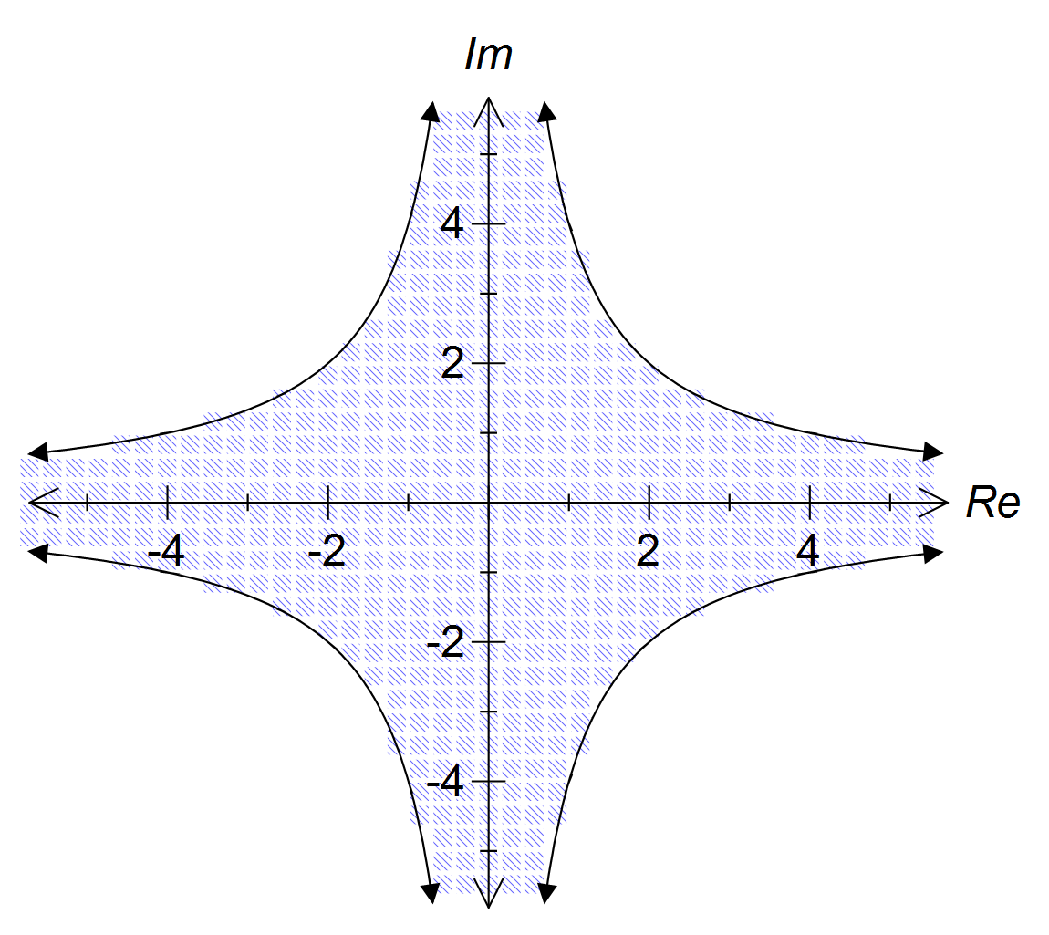
Specific behaviours
correct plotting of xy =4
correct plotting of xy = -4
solid line and correct shading

Question 12 (8 marks)

(a) According to research carried out by a company the proportion of households switching between oil, gas and electric heat in the United States after 1 year is shown in the table below.

 |  | To
 |  | Oil | Gas | Electric
From | Oil | 70% | 30% | 0
 | Gas | 10% | 80% | 10%
 | Electric | 20% | 0 | 80%

If the pattern of switching types of heating continues

(i) determine the proportion of current households using gas who will be using gas in 5 years time.
[2]
Solution
50.3%

Specific behaviours
Sets up transition matrix from table and raises to the power of 5
correct proportion of households

(ii) determine in the long term what proportion, to 1 decimal place, of
households will be using each of the three forms of heating?
[2]
Solution
Oil 30.8%, gas 46.2% and electric 23.1%

Specific behaviours
determines steady state matrix
correct proportions for each method of heating

(b) A farmer is breeding marron in one of his dams. He has collected the following data on
their breeding and survival rates in 2003.

Age (years) | 1 | 2 | 3 | 4
Population | 750 | 1200 | 900 | 600
Birth Rate | 0 | 0.7 | 1.4 | 0.5
Survival Rate | 0.7 | 0.6 | 0.5 | 0

- Construct a Leslie matrix, L, to represent this population.
[1]
Solution
Specific behaviours
correctly sets up matrix from information in the table

- What is the total population in 2009?
[1]
Solution
The total population in 2009 is approximately 5123 marron.
Specific behaviours
correct total population

(iii) Over a period of time the population growth reaches a steady state of 6.5%. If in the long term the farmer wishes to maintain a stable population level in the dam what culling rate of each age group will the farmer need to set?
[2]
Solution
Let k be the proportion surviving after the cull
∴ The culling rate will need to be 6.1%
Specific behaviours
correctly determines k
correctly determines the culling rate

Question 13 (6 marks)

The velocity of a particle that travels in a straight line is given by , where v is in m/s and t is in seconds.

(a) Determine the times when the particle is at rest.
[2]
Solution
Specific behaviours
recognises that t = 0 when the velocity is at rest
correctly determines the two times the particle is at rest for

(b) If the particle was initially at the origin determine an expression for its displacement.
[2]
Solution
Specific behaviours
integrates velocity to determine displacement
correctly determines the value of the constant and hence states the expression

(c) Determine the distance the particle travelled in the third second.
[2]
Solution
Specific behaviours
integrates the absolute value of the velocity over the appropriate lower and upper limits
correctly determines the distance travelled in the third second

Question 14 (5 marks)

The diagram below shows parallelogram ABCD where and .
Point X divides DB internally in the ratio 2:1.
Point M is the midpoint of AB.
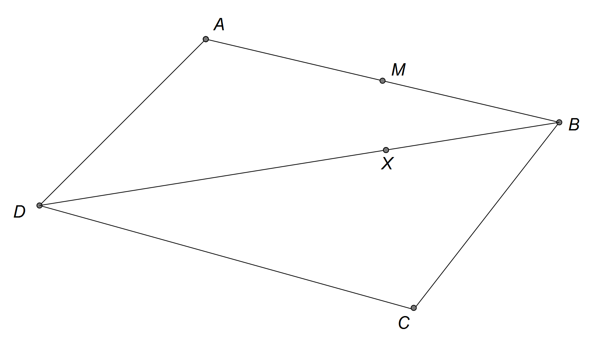

(a) Show that
[1]
Solution
Specific behaviours
correctly shows

(b) Find in terms of a and b.
[1]
Solution
Specific behaviours
determines correctly

(c) Prove that points M, X and C are collinear.
[3]
Solution
Specific behaviours
determines an expression for in terms of and
shows is a scalar of
deduces the required result

Question 15 (5 marks)

A certain type of electronic circuit will remain in a stable state if the values of two variable resistors, x and y, satisfy the equation .
In a particular circuit, the value of y is increasing at a rate of 15 units per second. At what rate must x be changing when y = 1000 for the circuit to remain stable?

Solution
OR
x is decreasing at a rate of 0.9375 units/sec
Specific behaviours
correctly determines expression for
correctly differentiates with respect to t
correctly determines expression for
correctly determines x when y = 1000
correctly calculates
statement correctly interpreting the
rate is decreasing

correctly determines x when y = 1000
uses chain rule with OR
correctly calculates
statement correctly interpreting the
rate is decreasing

Question 16 (6 marks)

A line and a plane are given by and .

(a) Given that the point (2, c, -2) lies on the plane determine c.
[2]
Solution
Specific behaviours
substitutes point into equation of plane
✓ correct value of c

(b) Find the position vector of the intersection between the line and the plane.
[2]
Solution
Intersect when

Specific behaviours
correctly determines value of λ
✓ correct point of intersection

(c) Find the acute angle between the line and the plane.
[2]
Solution
Find angle between line and normal to plane:

Specific behaviours
correctly determines θ
✓ correctly determines the acute angle between the line and plane

Question 17 (6 marks)

The graph of is shown below
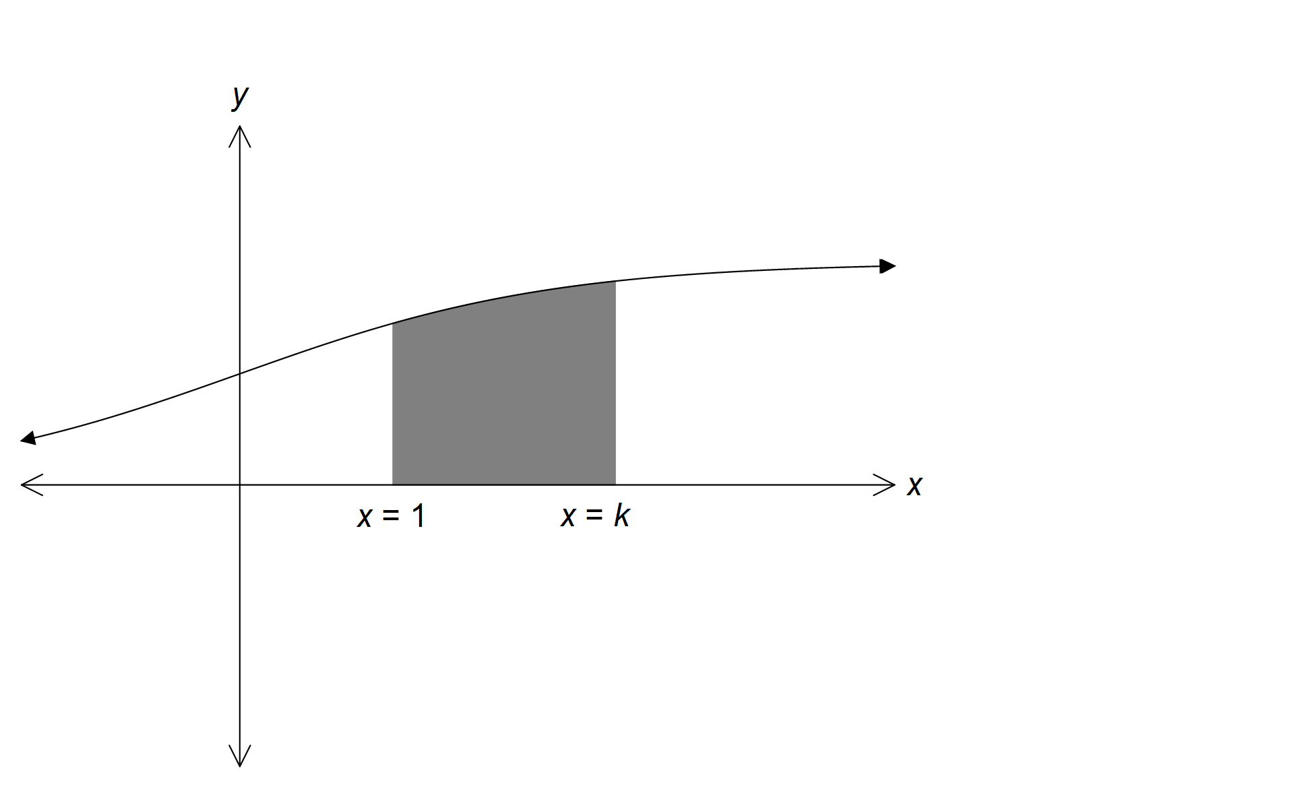

(a) Show that the area enclosed between the curve f(x) and the x-axis between x = 1
and x = k, is .
[3]
Solution
Specific behaviours
recognises and integrates correctly
substitutes upper/lower limits
uses log laws to simplify expression and deduce required result

(b) The graphs of f(x) and are shown below. Determine the area bound by the two curves and the line x = 2.

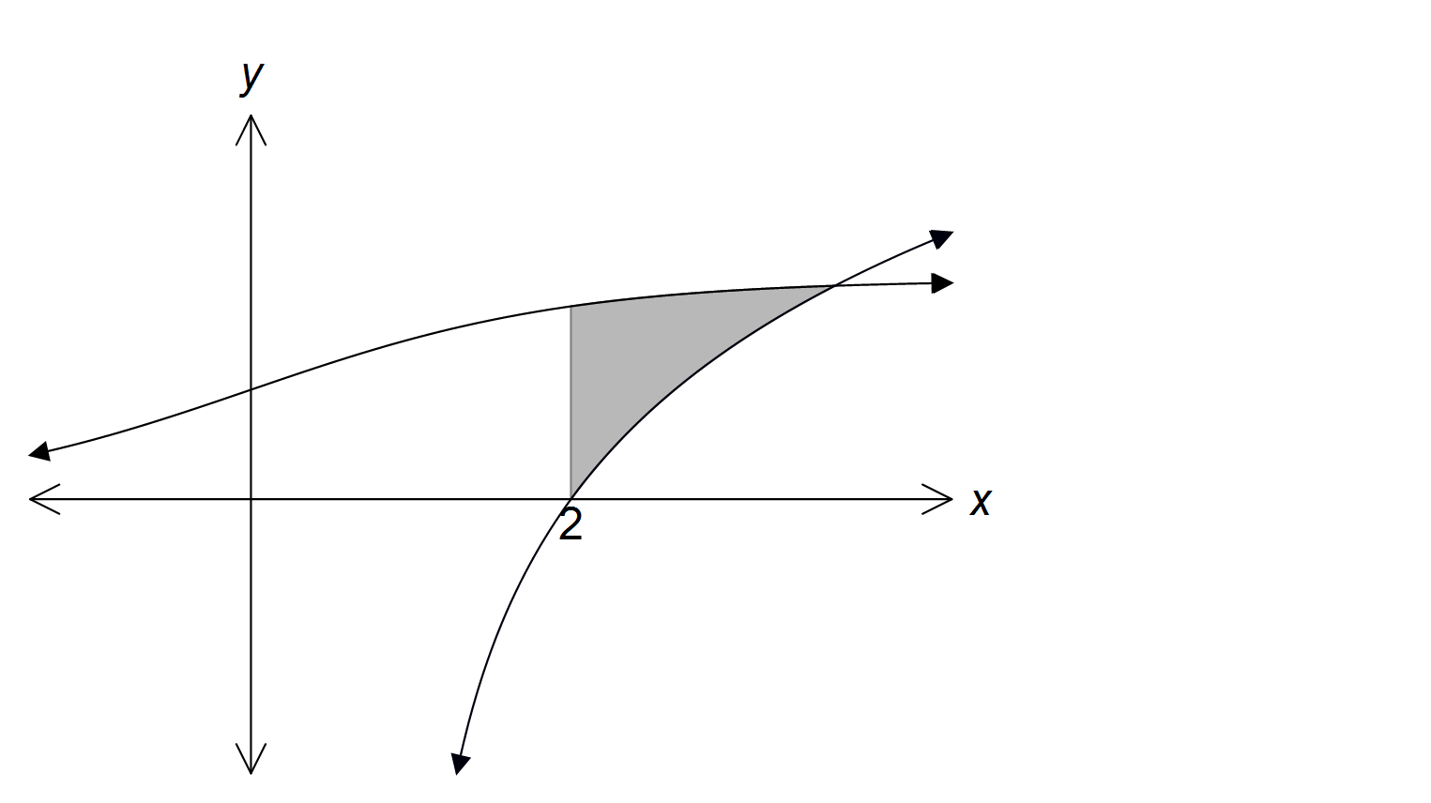

[3]
Solution
Value of x at point of intersection x ≈ 3.650
Specific behaviours
determines x value at point of intersection of functions
determines an expression for the area between the curves
correctly determines the area of the required region

Question 18 (10 marks)

An object, P, has an initial position of metres and is moving with a constant velocity of metres per second.
(a) A second object, Q, is moving with constant velocity of metres per second and collides with object P after six seconds.

Determine the initial distance apart of object P and object Q.
[4]
Solution
P and Q collide at

Hence initial position of Q is at

Distance between P and Q is
Specific behaviours
determines point of collision
✓ determines r_{Q}
determines _{Q}r_{P}
determine correct distance between P and Q

(b) A third object, R, is initially located at metres and is also moving with a constant velocity metres per second. Determine the value of x such that after 5 seconds the distance between objects P and R is minimised. State the minimum distance at this time.
[6]
Solution

Hence for the distance to be minimised after 5 seconds x = 5.6.
The minimum distance is 19.4 m

Specific behaviours
determines r_{P} when t = 5
✓ determines r_{R} when t = 5
determines _{P}r_{R} when t = 5
Recognise need to find minimum of ⏐ _{P}r_{R}⏐
correct value of x
correct minimum distance

Question 19 (5 marks)

The solution to the differential equation passes through the point where x = 0 and y = 2. Determine y when x = 1.

Solution
Specific behaviours
separates variables
✓ correctly determines antiderivatives
applies log definition
substitutes (0, 2) to calculate constant
deduce required result

Question 20 (10 marks)

(a) One of the solutions to the equation is shown on the graph below.
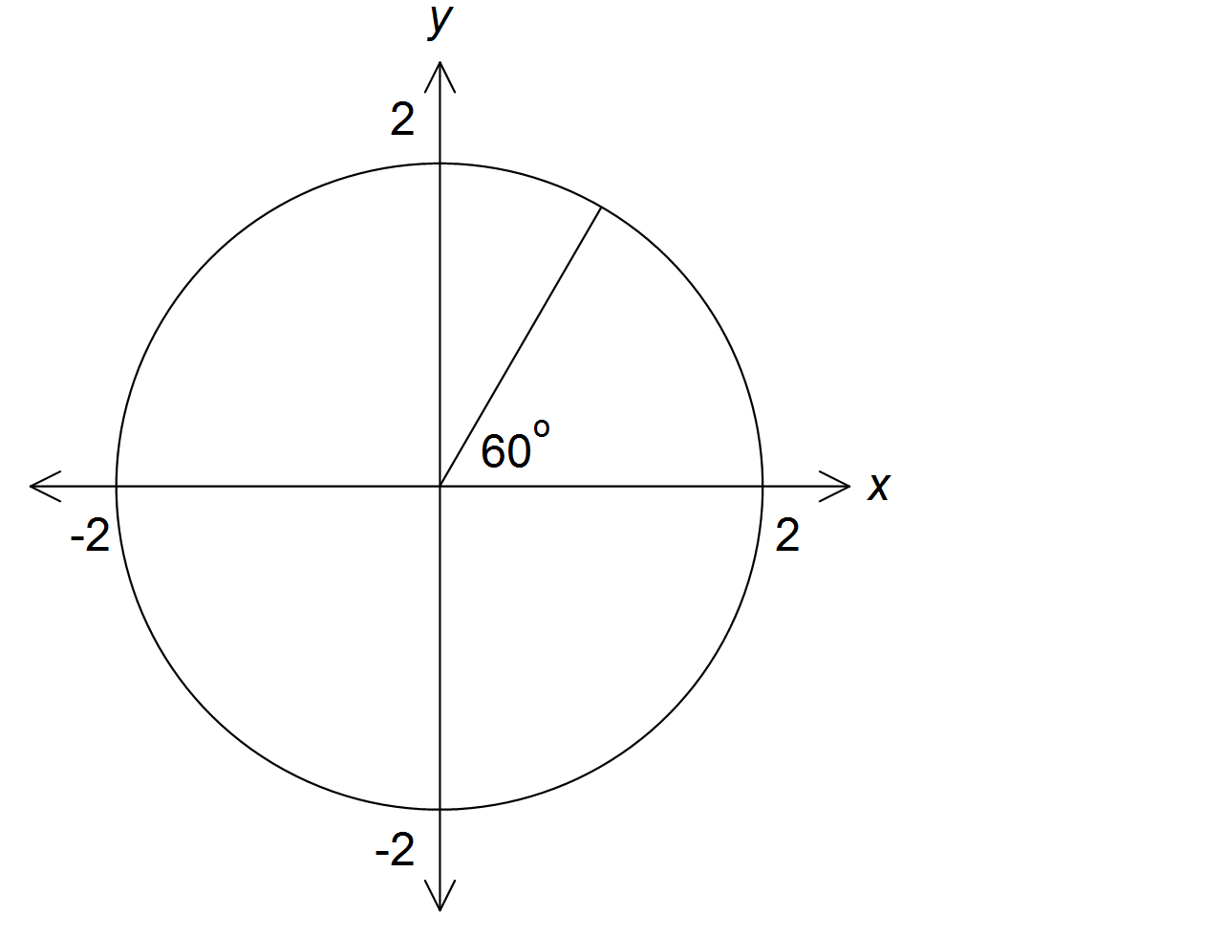

(i) Make a sketch of the remaining roots on the axes above.
[1]
Solution
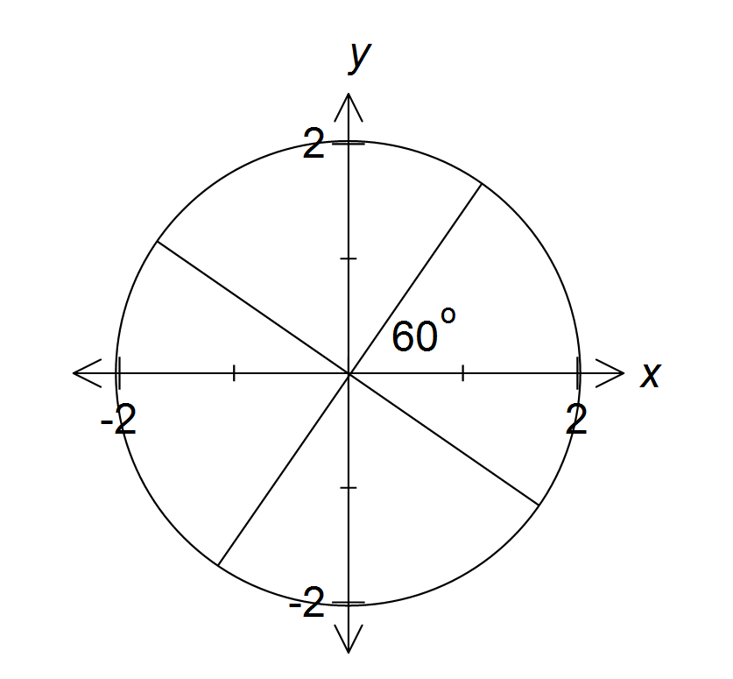
z₃
z₁
z₂
z₀
Specific behaviours
correctly places remaining 3 roots on axes

(ii) Determine algebraically the value of k in Cartesian form.
[2]
Solution
Specific behaviours
determines k in polar form
✓ determines k in Cartesian form

(b) (i) Solve algebraically, using de Moivre’s theorem giving your answers in
Cartesian form.
[5]
Solution
Specific behaviours
Expresses $z^{3}$ in polar form
Expresses $z$ in polar form
three roots in polar form (only for 2 roots in polar form and 0 for 1 root)
each root in Cartesian form

(ii) Solve algebraically.
[2]
Solution
Specific behaviours
recognises solutions are translation on , real component by -1
correct four solutions in Cartesian form

Additional working space

Question number(s):

Additional working space

Question number(s):

